


Module 6 - Braille

In this Module students examine the use of Braille to provide an integrated and interactive language learning approach. The Module incorporates cross curricula outcomes based on Technology and Enterprise through the exploration of how the production and distribution of Braille is achieved through the use of computers and assistive Technology.

The following information has been drawn from the Western Australian Curriculum Framework Document and associated Curriculum Guidelines to help teachers place the module in context.

ENGLISH
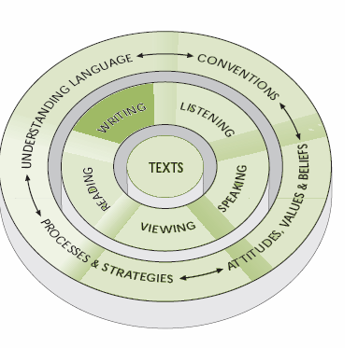
WRITING
……Students write for a range of purposes and in a range of forms using conventions appropriate to audience, purpose and context….

……Students write to communicate ideas and information; share experiences; express their thoughts, feelings and ideas in a variety of ways; using techniques for producing texts, such as handwriting, keyboarding and word processing…..

……style and structure associated with different forms of writing such as reports, letters, stories, essays……
…..They take into account purpose, audience and context when planning, shaping and presenting their work and adapt their language for different purposes, audiences and contexts…..

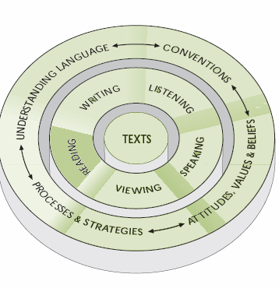
READING
…..Students read a wide range of texts with purpose, understanding and critical awareness…..

….Students read a wide range of materials, including signs, billboards, notes, messages, memos, instructions, reports, newspapers, magazines, CD-ROMs, Web pages, essays, text books, fairy stories, picture books, myths, legends, fables, biographies, autobiographies, novels, stories, poetry and drama…..

…..Students read to obtain information, to develop knowledge, for enjoyment and as a means of reflecting on experience. They use a range of different reading strategies, varying these strategies according to their purpose for reading and the nature of the text…..

…..Students may, for example …make meaning from familiar signs and notices; read and follow a set of instructions in order to complete a task; collect appropriate information from an encyclopedia for use in a project; read an article in a newspaper and explain it to classmates…..

TECHNOLOGY AND ENTERPRISE

TECHNOLOGY IN SOCIETY
Students understand how cultural beliefs, values, abilities and ethical positions are interconnected in the development and use of Technology and Enterprise.

……Students evaluate the appropriateness of technologies on ethical and moral grounds, as well as considering economic advantage and the suitability of products, processes, systems, services and environments for individuals and groups at local, national and international levels….

SOCIETY AND ENVIRONMENT

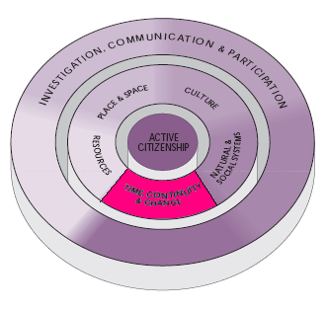

TIME, CONTINUITY AND CHANGE
Students understand that peoples’ actions and values are shaped by their understanding and interpretation of the past.

…...Students recognise that by studying people and events of the past, they can better understand the present and make informed judgments about the future….

….They realize that people’s ideas and values are influenced by the actions and values of those who have come before them….

…..Students can, for example, identify significant activities and events in their personal and family life or in their local community over recent generations; trace the impact and contribution of a group or individual on a community or society; and explore the impact of technological and economic developments…..

